1. The definition of the Chebysheve polynomial is as follow:

y=cos(m*cos-1(x)).

Where x has a value between [-1, 1] with the step 0.2. When the value of m changes from 1 to 5, we can get five curves T1(x) ~ T5(x) as the figure 1.

1. Please draw these five curves on the same figure, remember to use the legend command to identify each curve.
2. Please get the graphic handle of T2(x), and use it to change the (i) color, (ii) linewidth, (iii) line type of T2(x).

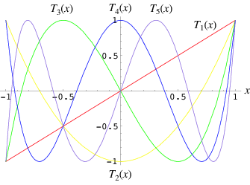

Figure 1

1. Use the MATLAB command to draw a surface plot of the following functions:

z = x*exp(-x2-y2)

Where x is equally divided into 21 points between [-2, 2], and y is equally divided into 21 points between [-1, 1], so this surface has 21*21=441 points.

1. Use the ‘meshgrid’ command to build up a meshgrid in the x-y plane.
2. Plot the surface and the mesh of the z(x,y).
3. To rotate your surface plot at fix elevation angle at pi/4 degree, and variable azimuth angles between [-pi, +pi] with the step of pi/10.
4. you can use the gradient function to estimate the derivatives and draw the gradient by using common ‘quiver’ in the same figure with the contour plot, adding the color bar of the contour.
5. Explain the physical meaning of gradient field.



Fig 2.

1. (a) Use the ‘Curve Fitting app’ with common ‘cftool’ to estimate the best fitting parameters of the data by utilizing the following two models:
2. y = a1*xb1+a2*xb2
3. y=(x-a) n+c

, and you are given the data:

|  |  |  |  |  |  |  |  |  |  |  |
| --- | --- | --- | --- | --- | --- | --- | --- | --- | --- | --- |
| x value | 1 | 2 | 3 | 4 | 5 | 6 | 7 | 8 | 9 | 10 |
| y value | 2 | 14 | 43 | 90 | 170 | 250 | 378 | 530 | 715 | 870 |

1. Use the best fitting to predict the value of y given x=15.
2. Explain the value of SSE and R-square in the Goodness of fit.